Thingspeak

login : [community@sl2square.org](mailto:community@sl2square.org)

Password : commlabWifi1

Link : <https://thingspeak.com/channels/431893/private_show>

API:

Write Key

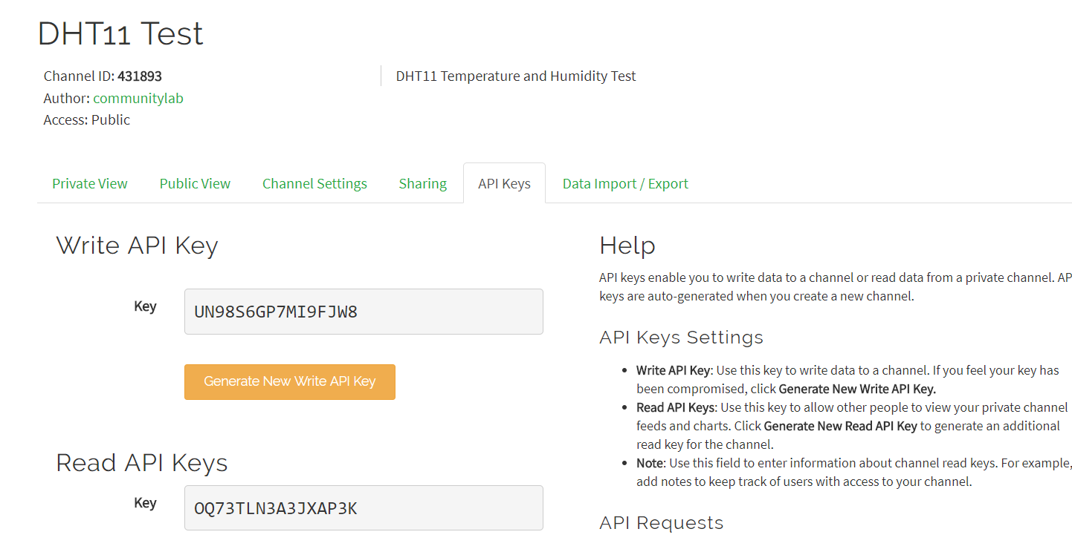

TalkBack Key

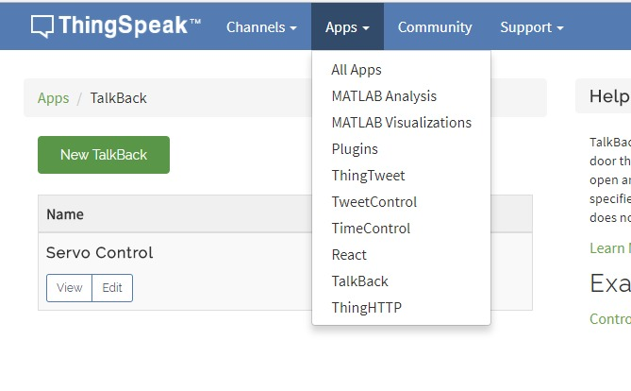

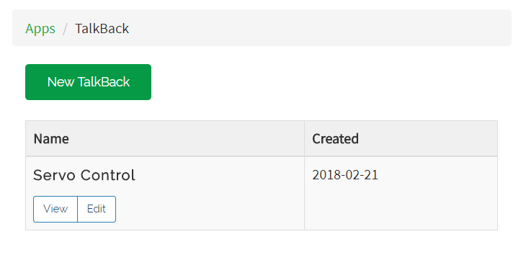

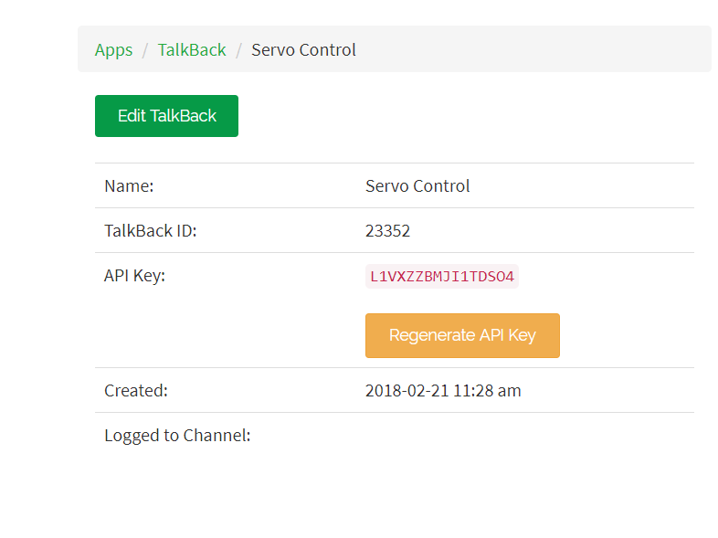

You need ARC - Advanced Rest Client

<https://install.advancedrestclient.com/#/install>

Import the data file “arc-data-for-testing.json”

File >> Import data

This is use for testing.

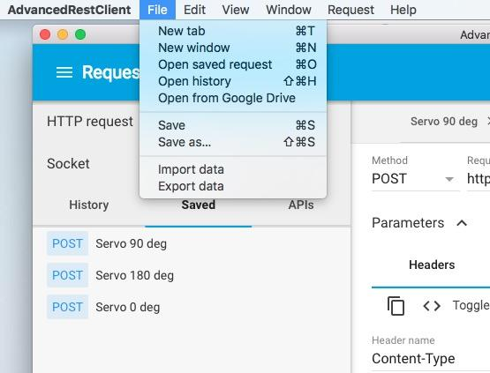

Somehow there is some error in the import..

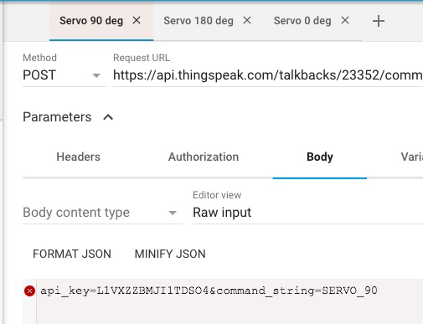

Fix it by changing body content type to “application/x-www-form-urlencoded”



Suppose to look like that, do it for all 3.



Then press send to move the servo.. You should see ok

